**HIGHLIGHTS**

**OF THE**

**HAMRA FAMILY**

**After all these years having the brief history of the Hamra Family written by Mr. Richard A. Hamra in 1979. I felt it is a duty to pass along this information to family members, and to, all whom it may concern, exactly as written by Mr. Richard Hamra, hoping that this information sheds some light on the migration of the MARJEOUNI Families, starting the latter part of the third century.**

**Najib C. Hamra**

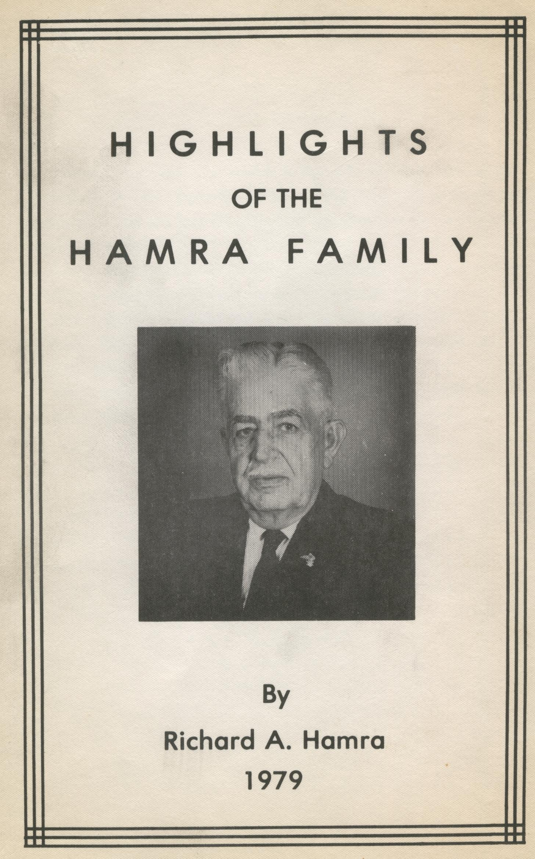

**ACKNOWLEDGEMENT**

**I owe a great debt of gratitude to my wife Nellie for typing the names of the old generation in the family ledger. It is also with great pleasure and love that I declare and proclaim the family tree and history dedicated to my wife.**

**I also owe a debt to my beloved cousin Haleem Hamra, and to Uncle George Assaf Hamra for assisting me in many ways.**

**Also the many friends and acquaintances from many parts of the Middle East and America whose aid I sought and received, my thanks.**

**Needless to say, any errors or shortcomings are entirely my responsibility.**

**Richard A. Hamra**

**1979**

**HIGHLIGHTS OF THE HAMRA FAMILY**

**BY**

**Richard A. Hamra**

**INTRODUCTION**

The task of tracing the significant events of the history of the **Ghassan** Kingdom was far from an easy one. The difficulty was in how to keep in, through the maze, the golden thread which entwines this chronicle of the **Ghassani** who had normally been viewed as an adjunct to other Syrian Arab tribes. If this attempt of sifting through available data, utilizing its essential elements, interpreting the information into the whole of the **Ghassan Kingdom of Hawran** serves as a basis and background for the understanding of the many problems that beset the people in those localities then, the effort would not have been in vain.

If it is true that no present can be understood without the study of the past, it is equally true that no past can be understood without adequate acquaintance with the present. Thus, this is an attempt to understand the relationship between two points in history, together with the intervening years.

Much of the information for this chronicle was acquired and gained in the visit in 1937 to Lebanon, Syria, Palestine, Jordan, and Jabel Druze. This tour served to refresh the memory of ancient and historic scenes and provided direct contact with the people of the countries. Conversations with the older generation whose ages ranged from 75 to 85 provided information in the oral history tradition. These “historians” reported learning the chronicle of the **Ghassani** people from their fathers and grandfathers wherein the **Hamra** family is a branch of the Ghassan Kingdom and emigrated from **Hawran** Syria to our home of **Judeideh Merjayoun.**

**THE CHRONICLE**

**Benu Ghassan** immigrated to **Hawran** Syria from southeast Yemen in the latter part of the third century. In the fourth century, the Ghassani were Christianized and appointed Lords of all Syria by Emperor **Justinian.** This appointment resulted from the fact that Al-Harith Ibn Jabala conquered Mundhir of Hira in 528. In the following year, Justinian perceived the value of the Ghassanis as an outpost of Roman Empire and as opponents of the Persian dependency of Hira. Thus, Justinian recognized Harith Ibn Jbala as King of the Arabs and patrician of the Roman Empire.

The **Ghassani Kingdom** reached its height and extended to many areas. The great Orthodox Church of **Antioch** and all the East, Mother of all Christian denominations oriented toward Constantinople enjoyed imperial protection and became known as **Melkite** (Royalist). The term Melkite is used today for that fragment which, under Roman Catholic missionary influence in the 18th Century, split from the Orthodox mother church to follow Rome. The Melkite Catholic Church continues to use the Eastern Orthodox Church liturgy.

When the Moslems were traveling in Arabia, their tradition made the **Prophet Mohammed** and his caravan pass through the Ghassani cities there to learn much of what he knew about Christianity. One of the Islamic poets who was sick fell under the good grace of the Ghassani who ministered to him and showered him with gifts. The poet reciprocated by singing praises in an oft-quoted verse extolling their military prowess. It is as follows:

**“No Fault is theirs Save that their Swords**

**Are Dull from Striking Hostile Hosts.”**

Another poet who spent many happy days in the court of Ghassani was Medinese **Hassan Ibn Thabit** who was poet laureate of the **Prophet Mohammed.**

The eastern shores of the Mediterranean Sea remained under Arab rule until the 11th Century. During this period, Jerusalem and the Christian Holy Land remained open for pilgrimages by Christians as allowed by the Arab rulers; however, in the very late part of the century, **Seljuk** Turks swept into the area, taking all of Asia Minor from the **Byzantine Empire** and occupying Arab Syria, including the Holy Land. Jerusalem was captured in 1071 and, thus, Christian pilgrims were not permitted to visit the sacred sites.

Concern for this situation was expressed by Pope **Urban II** and reached a climactic moment on November 26, 1095, when he delivered a passionate and fiery plea at Clermont in the southeast of France. The plea was made to the Christian believers that Asia Minor was to be returned to the Eastern Empire. The appeal attracted thousands of men under the command of European Knights who were determined to rescue the Holy Land from the Turks. Thus began the **First Crusade** comprised of religious zealots as well as the ambitious merchants who joined for material gains.

By the beginning of May 1097, the Crusaders were crossing the Bosporus and laying siege to the area of Asia Minor. The Crusaders were successful in their battles and continued their march to Jerusalem encountering strong resistance at **Antioch.** The attach on **Antioch** was long lasting from October 21, 1097, to June 3, 1098, with the capture of Jerusalem in late summer.

Following the capture of the Holy City, many Crusaders departed for their homes in Europe, leaving behind an insufficient army to protect Jerusalem. The city was recaptured by the Turks less than 50 years later – thus the Second Crusade was begun, stimulated by the preaching of **Saint Benard.** Due to diverse interests of the Crusading armies, the net result was failure – Jerusalem was still in the hands of Turks.

**Saladin** had gained power, reputation, and strength following successful conquests. His army soundly defeated a 20,000 man squadron on the sandy plains near Tiberia. This successful battle by **Saladin** yielded the capture of Jerusalem on October 2, 1187.

The loss of the Holy City aroused Europe and inspired the Third Crusade whose leaders were **Frederick** of Germany, **Phillip** of France, and **Richard the Lionhearted** of England. Legend and history have collaborated to make this campaign important – with **Richard** and **Saladin** as the heroes.

One of the truly spectacular and romantic periods in occidental and oriental annals involved the City of Akka (Acre). The Latin Crusaders under the command of Sir Guy attacked the city and with the new arrival of reinforcements from Europe, primarily Richard I army, the city fell. Saladin’s army was incapable of successfully defending the city, thus forcing Saladin to surrender. The conditions of the surrender included the restoration of the true Cross and the release of the garrison. Peace was concluded on November 2, 1192 – resulting in the Latin Kingdoms occupying the Coastal Areas as with the First Crusades, concession that Christian Pilgrims were not to be molested, with the non-coastal areas belonging to the Moslems.

**Richard** proposed the marriage of his own sister to **Saladin’s** younger brother with the understanding that the couple would receive Jerusalem and contiguous towns, including Akka (Acre). The result would bring to an end the Moslem-Christian conflict. The friendship between Richard and Saladin was deep indeed with Saladin being knighted. The wedding did not occur because Saladin died in 1193 at the age 55. He was buried in Damascus where his tomb is located near **UMAYYA** Mosque.

Meanwhile, the Crusaders who were living in Syria were enjoying great commerce and prosperity. The **Ghassani** never thought there would be way between the Crusaders and the Arabs because of the agreement and treaty executed by Richard and Saladin. During this period, the Crusaders who remained and lived in Syria socialized with the Ghassanies and other Arabs resulting in a mixed ethnic group of Europeans and Arabs (Semetic).

In the Thirteenth Century, the Moslem Arabs became stronger in population and manpower and began preparation for war to regain the lands lost in previous Crusades.

The Crusaders who were under-supplied and lacking adequate numbers to engage a formidable enemy decided to leave in order to save themselves and their fortunes.

The **Ghassanies** elected to stand and fight for their lands. Following several battles with their Moslem neighbors, and the loss of thousands of their own people, they were weakened to a point that migration to safer areas in the north was necessitated.

This migration commenced in the latter part of the 16th Century – beginning in **Hawran** in Syria and ending in **Jdeida.**

Today, these people are called **Hawarna.** The family names were taken from the branches or tribes of their ancestral **Ghassanies**, which are in current use. Among those who migrated north are the families who bear their tribal names that include:

**Rashid, Naifeh, Hamra, Barakat , Hazar,**

**Swaidan, Ayoub, Farha, Theeb,**

**Razzouk, Noffel, Khouri, Bayouth,**

**Deeba, Haddad, Samara,**

**Hamam, Kinaan, Edwan, Eid,**

**Jabara, Gholmia, Abla, Mosallam,**

**Farhood, Sayegh, Andeel, Kotite,**

**Rahhal, Jabbour, Salama, Abou Assi,**

**Wehbe, Shammas, Hourany and Zughyar.**

In their journey north, they reached a place called **Abu-Zibla** (ABO-ZIBLA), a cave. This particular spot was used as a rest stop for caravans traveling between **Jdeida** and Arabia, always loaded with merchandise. The elders of the families commissioned scouts to investigate the area further north. The reports were that a fierce war being waged between the rival Moslem families, the Shehabis and the Shi’ite (known to us today as Matawila).

The reputation of the **Shehab** family was one of trustworthiness and known to the **Ghassani** elders. Thus, an alliance was struck between the families wherein the Ghassani would fight the **Shi’ite.** The Shehabi were aware of the reputation of the Ghassani – one of prowess and skill in battle. The shi’ite were defeated by sword and lance. The grateful Shehabi offered to greatly reward their allies; however, the Ghassani limited the rewards and spoils of victory to a spot on a particular hill called **Jdeidet Merjeyoun.**

After the battle was won, some of the Ghassanie clans continued to travel north until they reached a town named **Zahla** where they decided to settle and build their homes.

Clan members consisted of the **Hamra, Abu Khater,** **Maalouf** and many other families. Several years later word reached the **Hamras** in **Merjeyoun** that their kinsmen were living in **Zahla.** This was very happy news to the three brothers, **Saad, Elias and Hanna Hamra.**

**Hanna** being the most courageous man in Merjayoun decided to go to **Zahla** and pay the clan a visit. His brothers advised him against making such a dangerous trip since there were no roads and trails were very treacherous. **Hanna** told them that he was not afraid of robbers and killers. He and his nephew **Faris** and six other well armed men to care for the camels loaded with gifts started on their journey riding Arabian horses. **Faris** was the son of grandfather **Saad.** The trip was very hazardous through the valleys and hills and mountain ranges. IT took three days to travel fifty-five miles as the heavy-laden camels moved very slowly. As they neared Zahla a scout approached and inquired as to who they were and why had they come. They replied that they were **Hamras** from Merjeyoun and wished to see their relatives whom they did not know due to the separation after the battle with the shi-ites. They were welcomed with great joy and happiness and renewed the relationship between the Ghassani clans. This was told to the author by Uncle Assaf (George) Hamra, who at the age of thirteen years remembered definitely that the meeting took place in August 1890.

In the United States the author renewed the relationship with the **Hamras** of Englewood, New Jersey, Meriden, Connecticut and El Paso, Texas. They have been guests at the Hamra Reunions on Reelfoot Lake, Tiptonville, Tennesee.

In the Lebanon Mountain area in 1860, the **Maronite** Christian peasants revolted against the DRUZE, a Moslem sect who were the overlords. This event resulted in the deaths of 12,000 Lebanese Christians. The tiny country was drawn into orbit of power politics. The Christians of MERJAYOUN were being led to the **Litani** River to their death when the battleships of five European nations:

Britian, France, Russia, Prussia and Austria, opened fire along the North Lebanon covering the area from the hills of Beirut to SAIDA (Sidon) TYRE (Sour), and MERJAYOUN. Realizing the continue slaughter of the Christians would result in losses of their own, the DRUZE withdrew and discontinued the harassment.

The five European nations joined Turkey in drafting a new satute for the government **of Lebanon.** The country was stripped of its seaports and the Bekau Plateau and put under a Christian Governor, called in Arabic, Mutaserrif.

As the years passed, a new corner was turned in Lebanon’s history – the country became an internationally recognized autonomous state. In this status, **Lebanon** contributed no troops to the Ottoman Imperial Army and paid no tribute to the treasury of the Turkish government.

After World War I, England and France conspired to divide Syria into five smaller countries – ones which were weak and not likely to rise again**. King George,** the Prime Minister of England, and the **General Allenby** and his high-ranking officers with **Lawrence of Arabia,** entered into an agreement with **King Hussein** and his sons, **Abdulla, Feisal, Ali** and **Zaid.** The agreement was that in return for Hussein’s help, England would provide financial aid and unite all of Syria from the Turkish border to the Persian Gulf.

England and France, instead, did not reunite all Syria, but rather completed the conspiracy of division. France took Syria and Lebanon; England gave Jordan to Abdulla; Iraq to Feisal and Palestine to England.

Lebanon increased in area by acquiring the coastline from Tyre (Sour) to Tripoli in the north to include Sidon and Beirut. Thus, the Christian Arabs from **Hawran,** descendants of the **Ghassani Kingdom,** became Lebanese by adoption after the country of Syria was divided.

**THE MIGRATION**

During the time the **Hamra** families lived in **Judeidet Merjayoun,** they established a thriving business. Saad, Elias, and Hanna, sons of Ghattas, migrated south to Transjordan where they began successful trade with the Arabs. Others of the family learned of the opportunities in America. Three young men of the family left for America in 1888. These pioneers were Mousa (Moses) son of Elias; Assad, son of Ghattas; and Yousef (Joseph), son of Nicola. (The names and dates of migration are included as an appendix to this manuscript.)

Among the early **Hamra** men who remained to care for the family business were Faris, Abdulla, and Nemetalla. Nemetalla emigrated to Brazil in 1911. Faris became a respected attorney with the law profession and well known among politicians and the citizens in the area. The Turkish government appointed him to the Circuit Court, a position he held until his death.

Abdulla the father of the author of this chronicle was respected by all Arabs regardless of tribal ancestry. He was consulted by many to settle misunderstandings and disputes. His advice, judgment, and decisions were accepted as final with no appeal.

The **Hamra family** has been known in most parts of Lebanon and in America for its Leadership, hospitality, and desire for learning and education.

Many occupy positions in corporations, serve as judges, and have entered the profession of law engineering, education, medicine, dentistry, pharmacy, and realty. Many others are successful businessmen and women.

In this country, the **Hamra family,** though scattered from coast to coast, are concentrated in the southeastern states – those states comprising the Southern Federated States.

The author of his chronicle, **Richard A. Hamra,** was appointed to write the constitution for the Southern Federation in conjunction with **Kamal Antone** and **Mitchell Tibshrany.** In 1941, a resolution was introduced and passed that the annual convention be held the first week of July, This tradition is currently observed.

**SUMMARY AND PURPOSE**

This writing is hoped to provide the reader and those of the future with a source of information about their family heritage – beginning in the **4th Century.** It is hoped that all – men, women, young and old – will read and remember their heritage. In order to preserve the heritage, the family established the **Hamra Homra** Family Club in 1950. During these ensuing years, the family has accomplished and succeeding in many ways to keep us united in love and respect for each other, primarily by the reunions and family dinners.

Through the Family Club, calls for help from the ancestral home of **Jdeidet Merjeyoun** have been answered. Among the projects supported by the Family were donation to the hospital, college, utilities installation, orthodox school, home for the Orthodox bishop, and St. George Orthodox Cathedral, and St. Peter Catholic Melkite Cathedral.

* * * * * * * * * * * *